# **Name: Abdurrahman Qureshi**

# **Roll No: 210451**

Practical No: 7

1) Find largest and smallest from a tuple

CODE:

myList = [83, 45, 73, 22, 85, 94]  
largest = myList[0]  
smallest = myList[0]  
for i in range(len(myList)):  
 if myList[i] > largest:  
 largest = myList[i]  
 if myList[i] < smallest:  
 smallest = myList[i]  
  
print(largest)  
print(smallest)

OUTPUT:

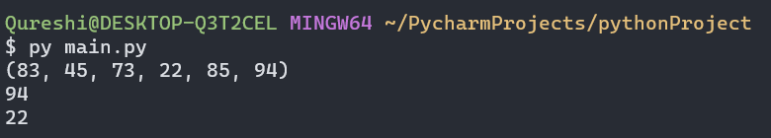

2) Find common from two tuples

**CODE:**

myTupA = (83, 45, 73, 22, 85, 94)  
myTupB = (87, 45, 71, 92, 85, 98)  
print(myTupA)  
print(myTupB)  
myTupC = list()  
for i in range(len(myTupA)):  
 if myTupA[i] in myTupB:  
 myTupC.append(myTupA[i])  
  
print(myTupC)

**OUTPUT:**

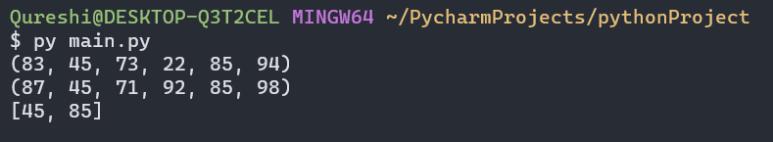

3) Print the number in words (Example: 1234 => One Two Three Four).

**CODE:**

n = int(input("Enter Multidigit number:"))  
rem=0  
while(n!=0):  
 rem = n%10  
 if rem == 0:  
 print("Zero")  
 elif rem == 1:  
 print("One")  
 elif rem == 2:  
 print("Two")  
 elif rem == 3:  
 print("Three")  
 elif rem == 4:  
 print("Four")  
 elif rem == 5:  
 print("Five")  
 elif rem == 6:  
 print("Six")  
 elif rem == 7:  
 print("Seven")  
 elif rem == 8:  
 print("Eight")  
 elif rem == 9:  
 print("Nine")  
 n = n//10

**OUTPUT:**

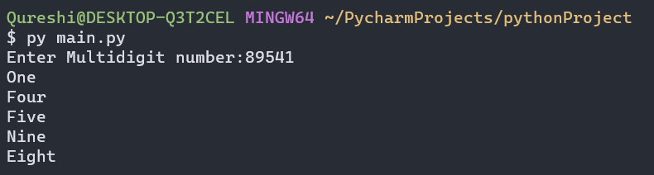

EXTRA QUESTIONS

1) Search a value

**CODE:**

myTupA = (83, 45, 73, 22, 85, 94)  
print(myTupA)  
  
valToSearch = int(input("Enter value to search: "))  
  
if valToSearch in myTupA:  
 print("Value is present ")  
else:  
 print("Value aint there")

**OUTPUT:**

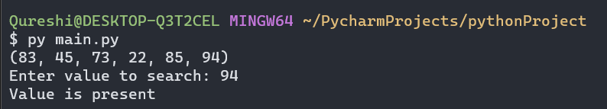 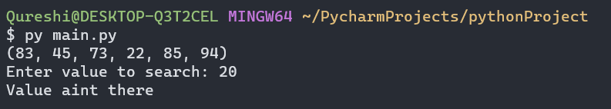

2) Combine two tuples

**CODE:**

myTupA = (83, 45, 73, 22, 85, 94)  
myTupB = ("q", "a", "r", "q", "9", "0")  
print(myTupA)  
print(myTupB)  
  
print(myTupA + myTupB)

**OUTPUT:**

